H.T.No:2303A51656
Batch 28
Task 1:
Prompt:
“Generate Python code to print all even numbers between 1 and N
using a loop.”
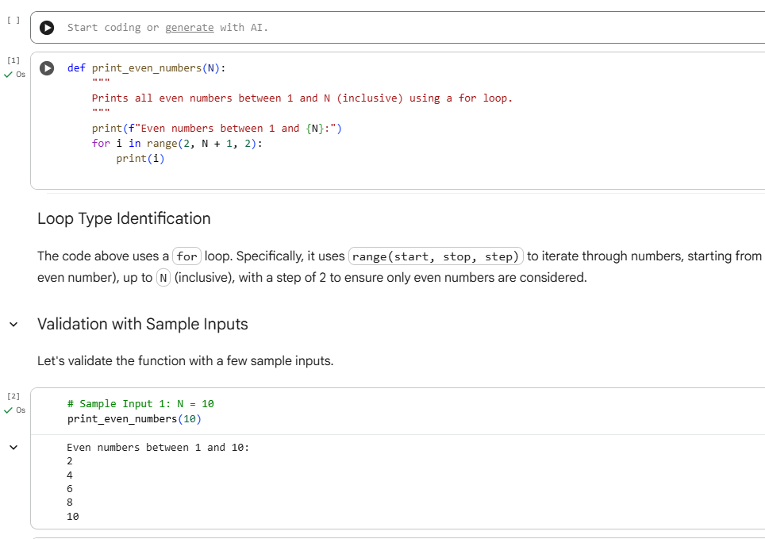
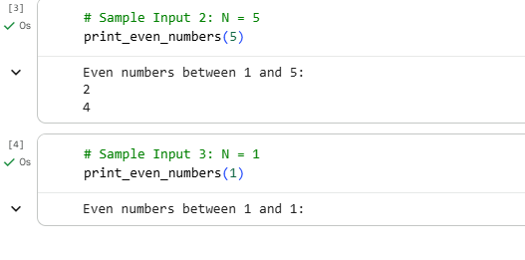
Task 2:
Prompt:
Generate Python code to count how many numbers in a list are even
and odd.
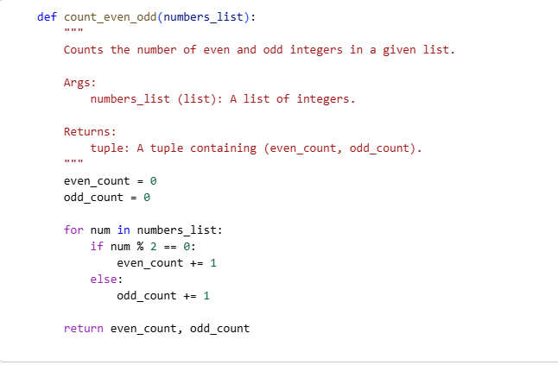
Explanation of Logic Flow
The count_even_odd function initializes two counters, even_count and odd_count, to zero. It then iterates through each number in the provided numbers_list using a for loop. Inside the loop, an if statement checks if the current number (num) is even by using the modulo operator (%). If num % 2 is equal to 0, the number is even, and even_count is incremented. Otherwise, the number is odd, and odd_count is incremented. Finally, the function returns both counts as a tuple.
Correct Count Validation
Let's validate the function with a few sample input lists.
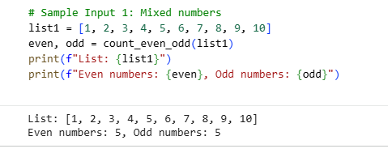
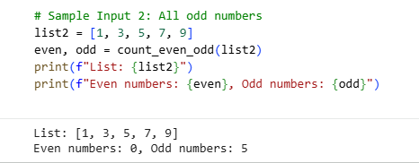
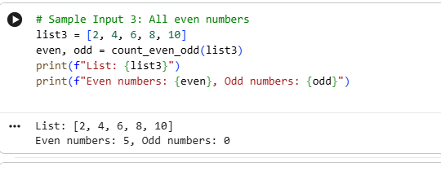
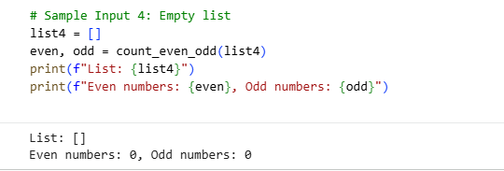
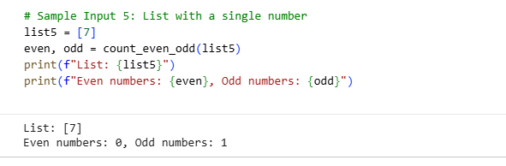
Task 3:
Prompt:
“Generate a Python class User that validates age and email using
conditional statements.”
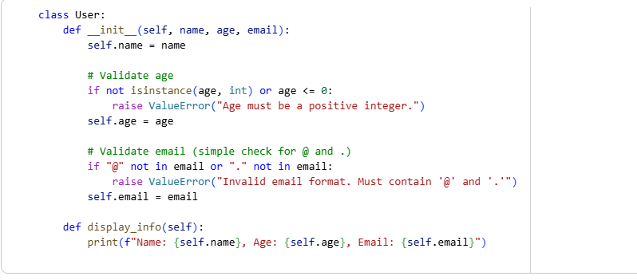
AI-generated Class with Validation Logic
The User class is defined with an __init__ method that takes name, age, and email as arguments. It incorporates conditional statements (if) to validate age and email before assigning them as attributes:
- Age Validation: Checks if age is an integer and is greater than 0. If not, it raises a ValueError.
- Email Validation: Performs a basic check to ensure the email string contains both an '@' symbol and a '.' (dot). If either is missing, it raises a ValueError.

Verification of Condition Handling and Test Cases:
Let's test the User class with various inputs to verify that the validation logic works as expected for both valid and invalid data.
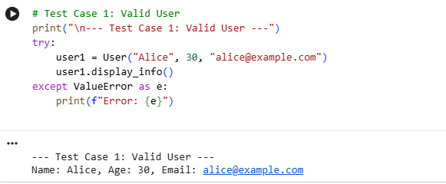
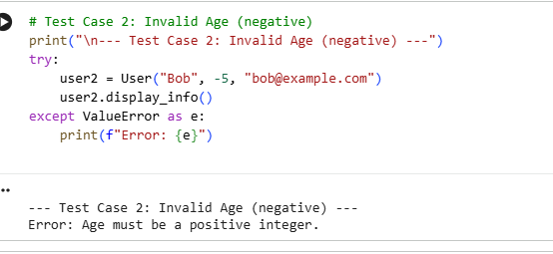
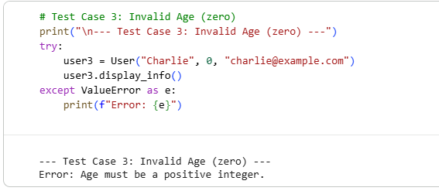
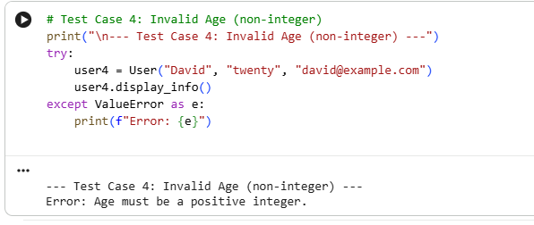
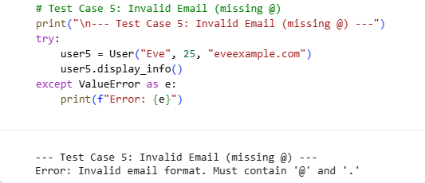
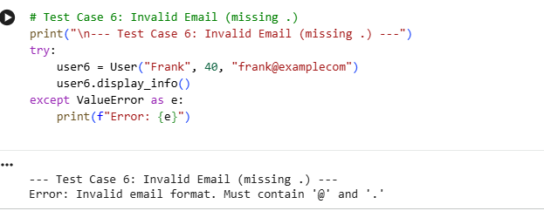
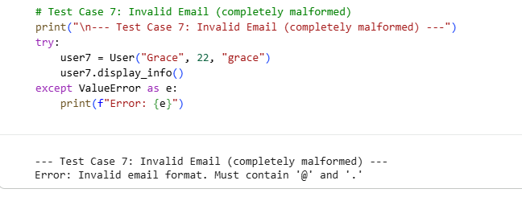
Task 4:
Prompt:
“Generate a Python class Student with attributes (name, roll number,
marks) and methods to calculate total and average marks.”
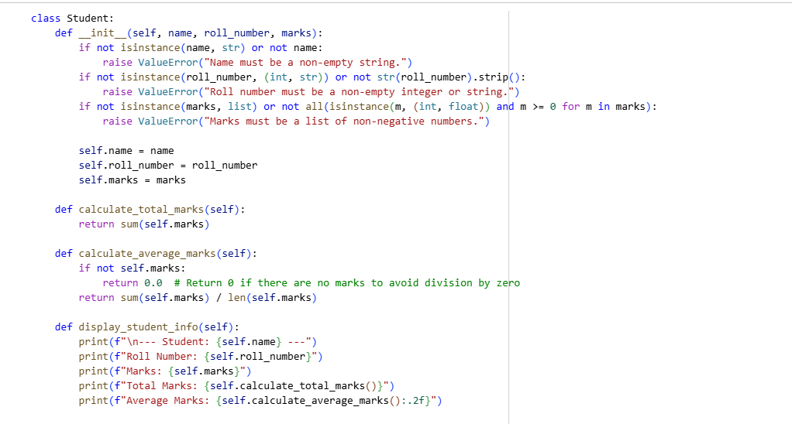
AI-generated Class for Student Management
The Student class is designed to manage student details including name, roll_number, and a list of marks. It includes validation for all attributes in the __init__ method:
- Name Validation: Ensures name is a non-empty string.
- Roll Number Validation: Ensures roll_number is a non-empty integer or string.
- Marks Validation: Ensures marks is a list of non-negative numbers.
It also provides two key methods:
- calculate_total_marks(): Sums all marks to return the total.
- calculate_average_marks(): Calculates the average of the marks. It handles the case of an empty marks list by returning 0.0 to prevent division by zero errors.
- display_student_info(): A utility method to print all student details, including calculated total and average marks.

Verification and Test Cases
Let's test the Student class with various scenarios to verify its correctness and attribute validation.
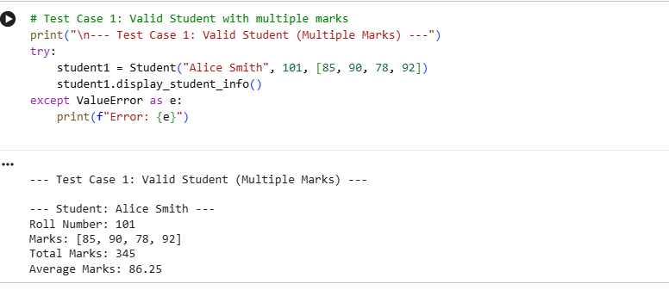
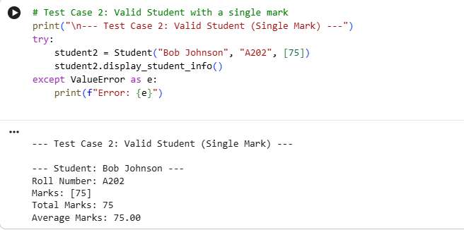
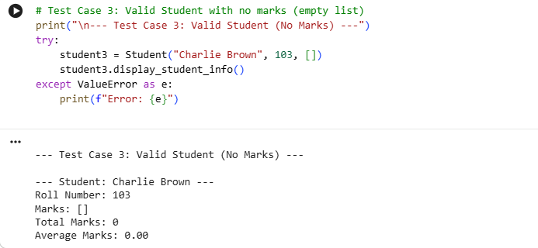
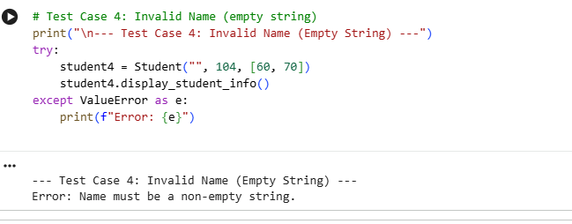
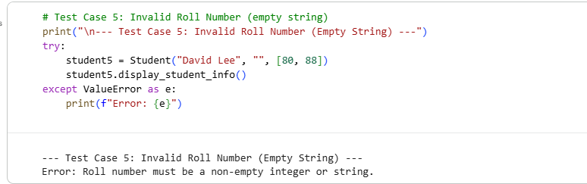
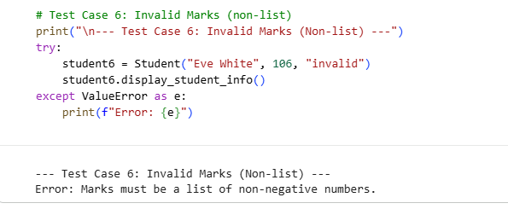
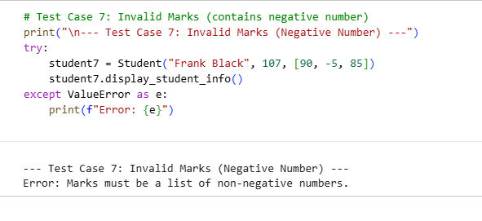
Task 5:
Prompt:
“Generate a Python program for a simple bank account system using
class, loops, and conditional statements.”
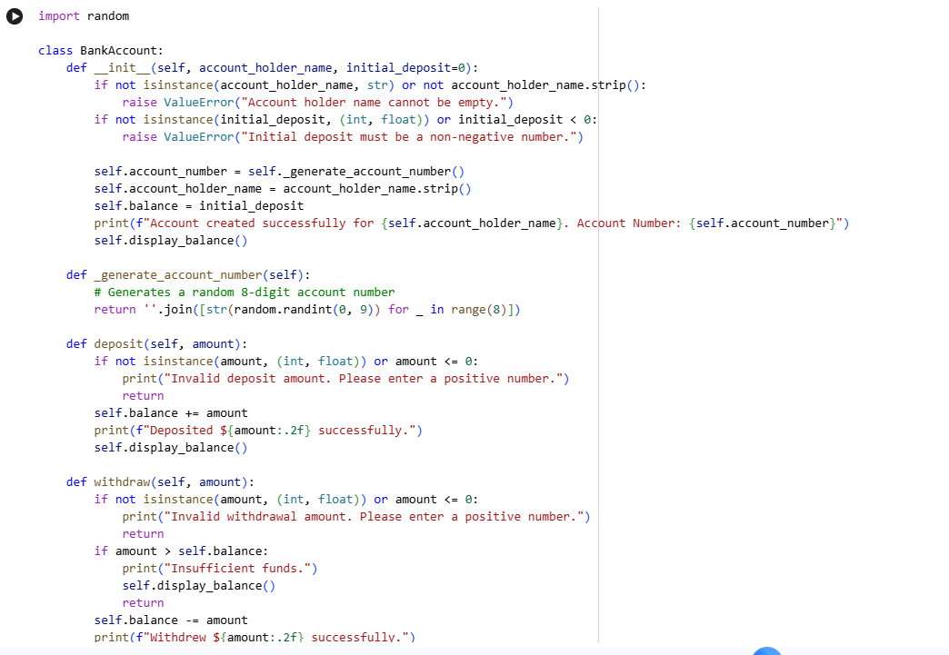
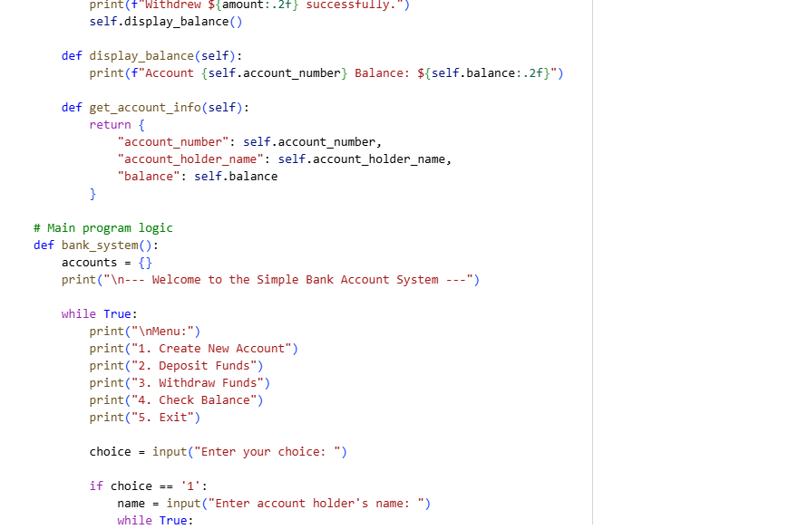
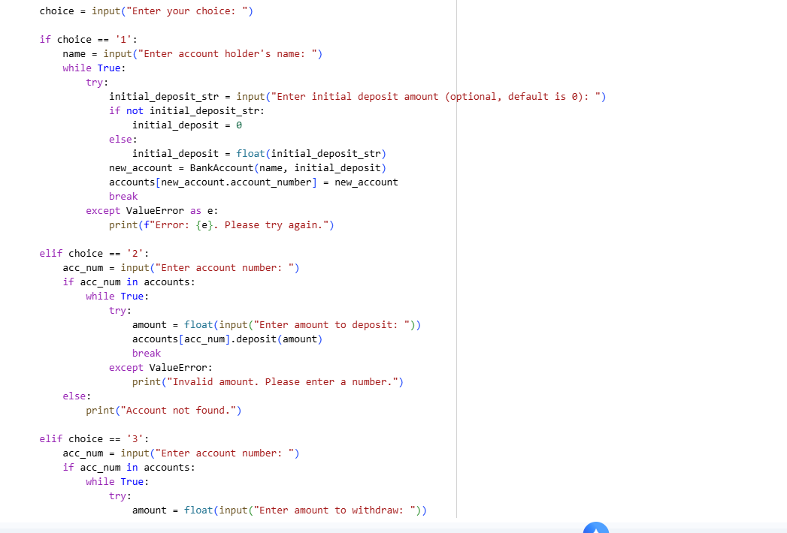
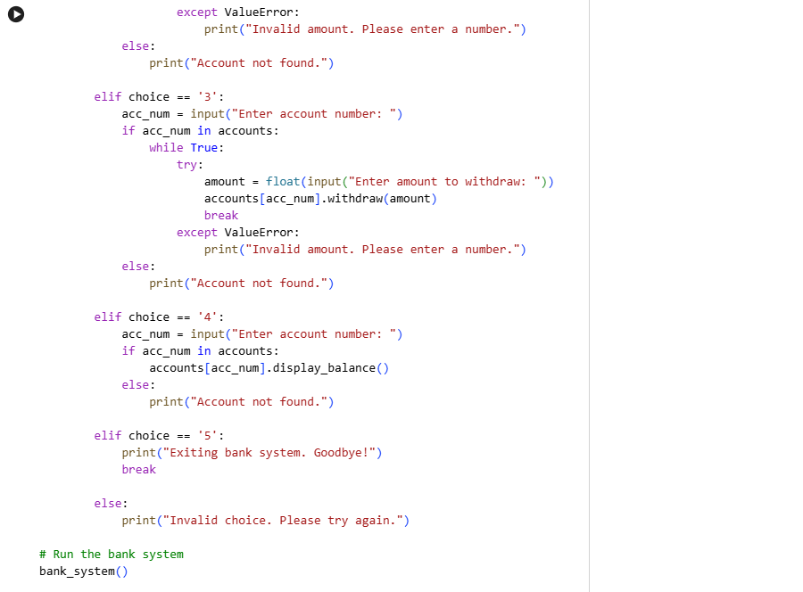
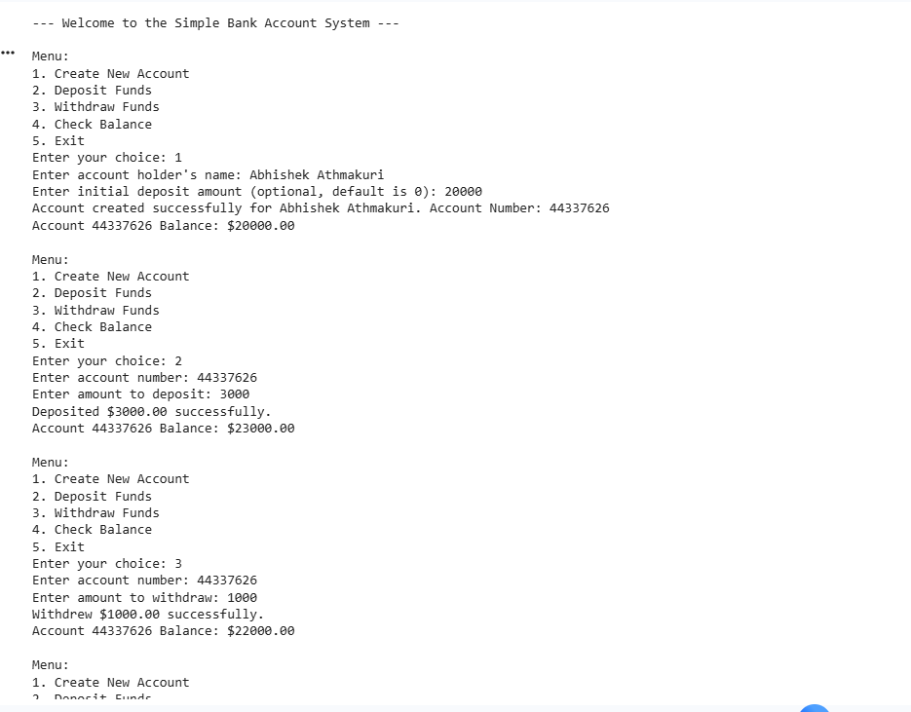
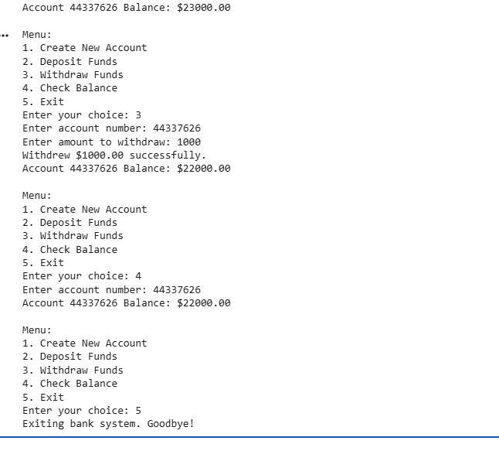
AI-Generated Program Review
Identification of Strengths and Limitations of AI Suggestions:
Strengths:
- Boilerplate Code Generation: The AI effectively generated the basic structure of the BankAccount class (__init__, deposit, withdraw, display_balance) and the main interactive loop (bank_system). This is a significant time-saver, handling repetitive coding patterns.
- Inclusion of Validation Logic: The AI proactively added validation for account creation (non-empty name, non-negative initial deposit) and transaction amounts (positive deposit/withdrawal, sufficient funds for withdrawal). This prevents common errors and makes the program more robust.
- Use of Core Concepts: It correctly integrated classes, for loops (within account number generation), while loops (for the main menu and input retry), and if/elif/else conditional statements for menu navigation and transaction logic, demonstrating a good understanding of the prompt's requirements.
- Error Handling: Basic try-except blocks were included for converting user input to floats, which is crucial for handling non-numeric input gracefully.
- Readability and Comments: The generated code is reasonably well-structured and includes docstrings and comments, contributing to readability.
Limitations:
- Simple Validation: While present, the validation is basic. For instance, email validation (not required in this prompt but seen in previous tasks) is very simple. In a real-world scenario, more complex regex or dedicated validation libraries would be needed. Similarly, account number generation is random and doesn't check for uniqueness (though unlikely for 8 digits, it's a theoretical limitation).
- Lack of Persistence: The bank account data (accounts dictionary) is stored only in memory and is lost when the program exits. A real-world system would require database integration or file storage, which the AI did not suggest as it wasn't explicitly prompted.
- Security: No security measures (e.g., password, encryption) are implemented, which is expected for a 'simple' system but a key limitation for a practical application.
- Edge Cases/Refinements: While initial_deposit=0 was set as default and len(marks) was handled in the previous Student class, more intricate edge cases or specific business rules might require more explicit prompting or manual refinement.
Reflection on how AI assisted coding productivity:
AI significantly boosted productivity in this task by:
- Accelerating Initial Setup: Generating the class and main program skeleton with core methods and loops took mere seconds, bypassing the initial setup phase that often consumes valuable time.
- Reducing Cognitive Load: The AI handled much of the routine coding, allowing me to focus on verifying the logic and considering potential improvements rather than writing every line from scratch.
- Serving as a 'Smart' Assistant: It anticipated common requirements like input validation and error handling, incorporating them without explicit instruction. This reduces the need for extensive debugging or refactoring later.
- Maintaining Consistency: The AI tends to follow common Python conventions and best practices for structure, leading to more maintainable code.
Overall, the AI acted as a highly efficient coding co-pilot, handling the foundational work and common patterns, thereby freeing up mental energy for higher-level design considerations and specialized customizations. The core functionality of the banking system was established very rapidly.

